Slow Cooker Chicken Broth

MichelleLeonardson.com │Where the Wine Is.

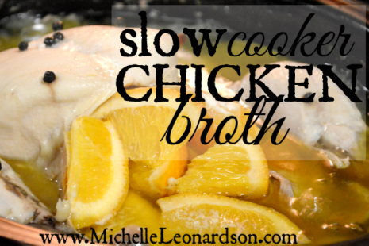

Ingredients
1 whole chicken
2-3 celery stalks
2 carrots
1 large onion
3 garlic cloves
10 peppercorns
1 bay leaf
1 orange
1/2 cube salted butter
4 cups water
1/3 cup white wine

Directions
Remove skin and giblets from chicken.
Wash and quarter each half of the orange, then stuff the chicken cavity.
Wash celery and carrots, then cut into large pieces. No need to peel carrots, just scrub then remove ends and any questionable spots. Peel and press garlic cloves:
Layer veggies on the bottom of a slow cooker and add bay leaf.

Place chicken on top of veggies. Add water and wine.

Cut butter into pieces. Top chicken with butter. Add peppercorns.
Slow cook on low for 8 hours.
Transfer chicken into a large bowl, let it cool, then pick away the fat, cartilage and bones. While the chicken continues to cool, use a colander to strain what’s left in the slow cooker. Rinse colander, line it with cheesecloth, and strain again.
Measure and pour the broth into freezer storage bags. Thaw and use as needed!

