Creamy Tomato Soup
MichelleLeonardson.com │Where the Wine Is.

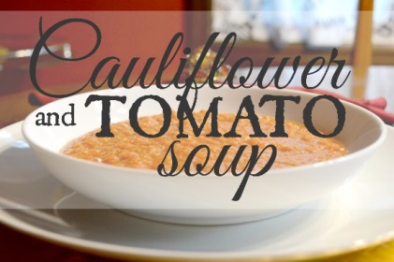

Ingredients

1 head of cauliflower, cut into florets
2 tbsp fat-free half and half (okay to substitute coconut, soy, cashew or almond milk)
1 tbsp butter
1 large can of tomato purée (or crushed tomatoes)
1 tbsp tomato paste
1/2 cup chicken broth (or vegetable broth)
1/4 cup wine
1/2 tsp sugar
1 tsp salt
1/2 tsp pepper
1 tbsp olive oil
1 onion, diced
1 red bell pepper, diced
1 garlic clove, minced
3 large basil leaves

Directions

In a large pot add tomato purée paste, broth, wine, sugar, salt and pepper. Heat on low, stirring occasionally.
Steam cauliflower florets until soft. Into a food processor add cauliflower, half and half, and butter. Blend until nice and smooth.
Add cauliflower purée to the tomato base and continue to stir occasionally.
In a pan, heat olive oil over low-medium. Add onion, bell pepper, garlic and cook until soft.
Blend veggies and basil leaves in food processor.
Add blended veggies to the soup. Turn heat to low-medium and let everything simmer for 30 minutes, stirring occasionally.

Serve and enjoy!

