Chardonnay Infused Mac n’ Cheese

MichelleLeonardson.com │Where the Wine Is.

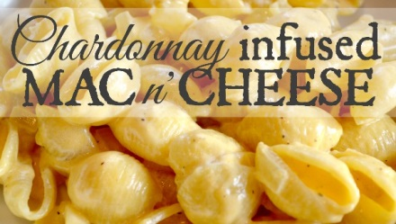

Ingredients

12 oz pasta
2 cups shredded cheddar cheese
½ onion, diced
2 garlic cloves, diced
3 tbsp butter
½ tsp salt
½ tsp pepper
1 tsp cornstarch
1 tbsp cold water
¼ cup Chardonnay
¾ cup cream (light or heavy to taste)

Directions

Prepare pasta as directed and set aside. Tip: stir 1 tbsp butter into the cooked pasta to keep it from sticking.

Sauté onion and garlic in 2 tbsp butter until onion is translucent.

Stir cornstarch into cold water.

Pour cornstarch, wine and cream into pan with onions and garlic.

Whisk in salt and pepper.

Add cheddar cheese before the cream thickens.

As cream thickens, slowly stir in pasta.

Serve and enjoy!

