(Apricot Brandy Bundt Cake)

MichelleLeonardson.com │Where the Wine Is.

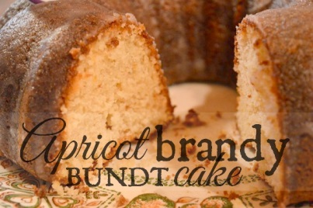

Ingredients

½ cup dried apricots, chopped
¼ cup apricot brandy
2 tbsp brown sugar
2 sticks unsalted butter, softened
2 cups sugar
4 eggs
2 tsp vanilla extract
2½ cup flour
2 tsp baking powder
1 cup milk

Directions
Soak chopped apricots in apricot brandy for 10 minutes. Bring to a boil and ignite. Wait for the flames to die. Turn stove heat to medium, then add brown sugar and stir until dissolved.
Transfer to a blender, add a stick of butter and blend. Pour into a large mixing bowl and set aside.
Sift flour in a separate bowl. Add baking powder and salt, stir and set aside.
Go back to your brandy butter and add sugar. Add the other stick of butter. Add eggs, mixing one in at a time. Add vanilla extract. Add milk and flour mix. Continue stirring until combined well.
Grease and flour Bundt pan.
Pour in cake mix and bake at 350° for 45 minutes. Use a toothpick to check whether batter has set.
Let it cool by popping the cake onto a rack under wax paper.
Mix ¼ cup milk and ¾ cup sugar to make a sugar glaze. Pour it all over the cake.
Serve and enjoy!

