Inspired Cinnamon Chicken

MichelleLeonardson.com│Where the Wine Is.

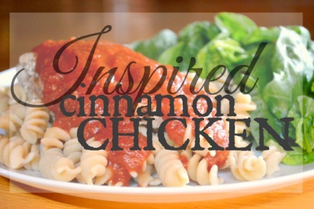

Ingredients
2 cups dry rotini noodles
1 tbsp olive oil
2 chicken breasts
1 tsp cinnamon
½ tsp salt
½ tsp cayenne pepper
¼ cup Cabernet Franc
½ jar marinara sauce

Directions
Cook noodles according to packaging and set aside. Add olive oil to keep cooked noodles from sticking.
Mix cinnamon, salt and cayenne pepper together. Sprinkle seasonings on each side of the chicken evenly.
Using a non-stick pan or a pan coated with cooking spray, heat the chicken between low and medium. Add a small amount of water to pan as needed so chicken does not burn.
When top of chicken begins to cook, flip chicken, cover pan with lid and continue cooking until chicken reaches 165°, or when you’re able to cut into the meat and find clear juices with no trace of pink. Set chicken aside.
Return pan to burner, set to low-medium heat and add Cabernet Franc. As the wine heats, use a spatula to whisk it to combine any spices left from the chicken. Add marinara and cook until it begins to bubble.
Plate noodles, top with chicken and sauce.

Enjoy!

