Turn Spaghetti Sauce into Chili

MichelleLeonardson.com │Where the Wine Is.

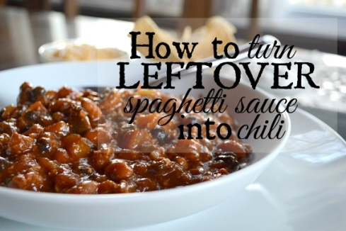

Ingredients
Leftover spaghetti sauce 1 cup water
1 yellow bell pepper, diced 1 can tomato sauce
1 jalapeno, diced 1 tbsp tomato paste
1 tbsp olive oil 1 tbsp Worcestershire sauce
¼ cup Merlot 1 bay leaf
1 can chili beans in sauce
1 can black beans, strained
1 tbsp brown sugar, packed
1 tbsp chili powder
½ tbsp cumin
1/8 tsp ground pepper
1 tsp salt
¼ tsp ground mustard
1/8 tsp crushed red pepper flakes

Directions
In a large pot soften bell pepper and jalapeno in olive oil over medium heat.
Add chili beans with the sauce from the can and the strained black beans.
Mix the spices in a small bowl (brown sugar, chili powder, cumin, red pepper flakes, ground mustard, ground pepper, salt). Pour them in the pot and stir well.
Throw in the leftover spaghetti sauce!
Finally add the tomato sauce, tomato paste, Worcestershire sauce, bay leaf and water. Stir it up nicely and cover!
Reduce the heat to low-medium and cook for one hour stirring occasionally.
Serve with shredded cheese, sour cream and corn chips!

