Thanksgiving Turkey Brine

MichelleLeonardson.com │Where the Wine Is.

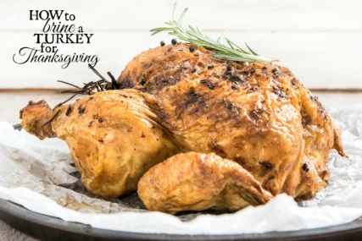

Ingredients

1 bottle of Riesling (preferably marked sweet or “Late Harvest”)
3 bay leaves
5 tarragon sprigs
6 sage leaves
1 tbsp peppercorns
4 crushed garlic cloves
1 cup brown sugar
1½ cups salt
1 quart water

Directions
In a large pot combine all ingredients and bring to a boil.
Stir well until salt and brown sugar have dissolved (about 5 minutes).
Remove from heat and add 1 gallon of water. This is your brine.
Let it cool to room temperature.
Pour brine into brining bag or oven roasting bag, then add turkey and tie bag closed.
If you have a large stockpot or a 5 gallon bucket AND you can make room for it in your refrigerator: Place the bag into the pot or bucket and put it in the fridge for 12-24 hours. Weigh turkey down until completely submerged.
You can use a cooler if you don’t have a proper pot, bucket or fridge space: Place the bag into the cooler and fill with ice. Keep refilling ice as needed to keep it at 40˚F for 12-24 hours, adding weight to the turkey as necessary to keep it fully submerged.
When the bird is ready to cook, take it out of the bag, discard the brining solution and rinse well.
Pat the turkey dry and prepare for roasting!

