30 Minute Meal | Asian Chicken Salad

MichelleLeonardson.com │Where the Wine Is.

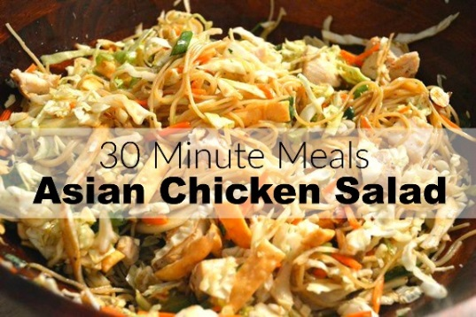

Ingredients

1 Asian style salad kit
1½ cups precooked chopped chicken
4 oz angel hair pasta
2 tbsp soy sauce
1 tbsp white wine vinegar

Directions

Cook angel hair pasta according to package directions.

Stir salad dressing in with the noodles. Cool in fridge for about 10 minutes.

Mix together soy sauce and white wine vinegar.

Dump the salad into a bowl and stir in sauce.

Combine noodles and salad, then add chicken, almonds and wontons.

Toss, serve and enjoy!

