Leftover Turkey N’ Gravy Bake

MichelleLeonardson.com │Where the Wine Is.

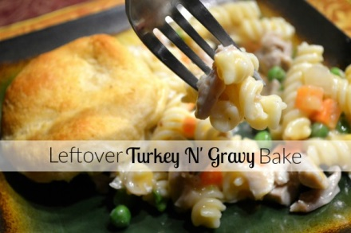

Ingredients

16 oz rotini pasta
2 cloves garlic, minced
½ onion, diced
⅔ cup white wine
2-3 cups leftover turkey, shredded
2 cups leftover gravy (or substitute cream of mushroom soup)
1½ cup shredded cheddar cheese
1lb bag of frozen peas and carrots
1 cup turkey or chicken broth
1 can Pillsbury Grands biscuits
2 tbsp butter, melted

Directions

Grease a 9x13 baking dish and pre-heat oven to 350°F
Cook pasta according to box directions and place it a large bowl, add a small amount of olive oil to keep pasta from sticking.
Sauté garlic and onion in wine until soft and add to pasta.
Chop turkey into bite sized pieces and add to pasta mix.
Mix in frozen veggies.
Gently stir in gravy and cheese.
Transfer to baking dish and add broth, drizzle evenly into mix. Bake for 15 minutes.
Halve the biscuits and place on top of the casserole. Brush melted butter on biscuits and return to oven for another 15 minutes, or until golden brown.
Serve and enjoy!

