Unbelievably Good Mashed Faux-tatoes

MichelleLeonardson.com │Where the Wine Is.

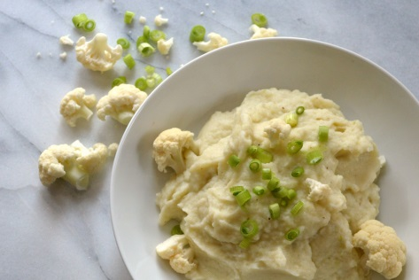

Ingredients

1 head cauliflower, cut into florets
6 scallions
3 tbsp almond milk
1 tbsp butter
¼ tsp salt
⅛ tsp black pepper

Directions
Steam cauliflower florets until soft (about 20 minutes).
Transfer florets to food processor and cover with lid.
Trim scallions at the stalk where they start to turn green. Set aside green leafy parts to slice for garnish.
Steam scallions for 5 minutes then add to food processor.
Add milk, butter, salt and pepper.
Mix until smooth!
Serve and enjoy!

