Slow Cooker Beef Stroganoff

MichelleLeonardson.com │Where the Wine Is.

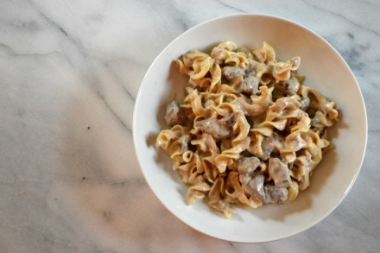

Ingredients

2 tsp olive oil
1 tsp kosher salt
½ tsp black pepper
2 tbsp all-purpose flour
1 ½ chuck roast trimmed and cubed into 1 inch pieces
1 yellow onion, diced
4 garlic cloves, minced
1 cup red wine
2 cups beef broth
1 tbsp Worcestershire sauce
1 3oz package cream cheese
1 package egg noodles

Directions

In a medium bowl mix salt, pepper and flour and coat the beef.
Heat olive oil in medium pan and brown beef on all sides for two minutes.
In the same pan add diced onion and minced garlic, sauté for five minutes.
Add wine to pan and use it along with a soft spatula to scrape loose bits.
Add wine, onion and garlic to slow cooker.
Add broth and Worcestershire sauce.
Cook on low in the slow cooker for 6-8 hours.
Add cream cheese and stir until evenly melted, then let it cook while preparing noodles according to packaging.
Add noodles to slow cooker and mix together with the sauce thoroughly.
Serve and enjoy!

