Quick Wine Cake

MichelleLeonardson.com │Where the Wine Is.

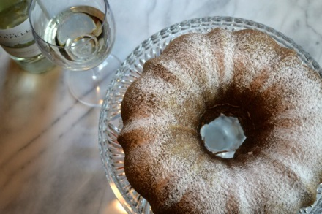

Ingredients

1 pkg Duncan Hines yellow cake mix
1 pkg Jell-O vanilla pudding
5 eggs
¾ cup vegetable oil
2 tbsp flour
1 cup white wine
½ tsp cinnamon if desired

Directions

Mix all together and beat 10 minutes with an electric beater.

Put it in greased and floured Bundt pan and bake for 60 minutes at 350°F.

Cool for 5 minutes.

Turn out on a cake plate.

Optional: Dust with powdered sugar.

Serve and enjoy!

